 https://img.meta.com.vn/Data/image/2021/08/20/co-quoc-ky-cac-nuoc-the-gioi-111.jpg

Q1:

Software Requirements Specification

for

<Project>[Student must replace this line by the name of project in the exam paper] (0.25 point)

Version 1.0 approved

Prepared by

<author>[Student must replace <author> by your full name and studentID] (0.25 point)

<organization>[Student must replace this line by the name of the FU Campus you take the exam] (0.25 point)

<date created> [Student must replace this line by the date you take the exam] (0.25 point)

Q2:

>

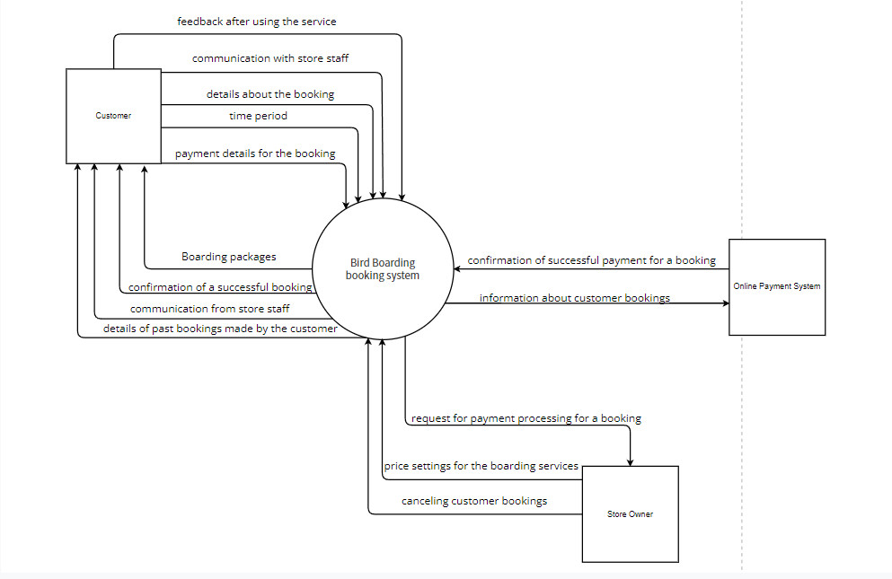

Q3:

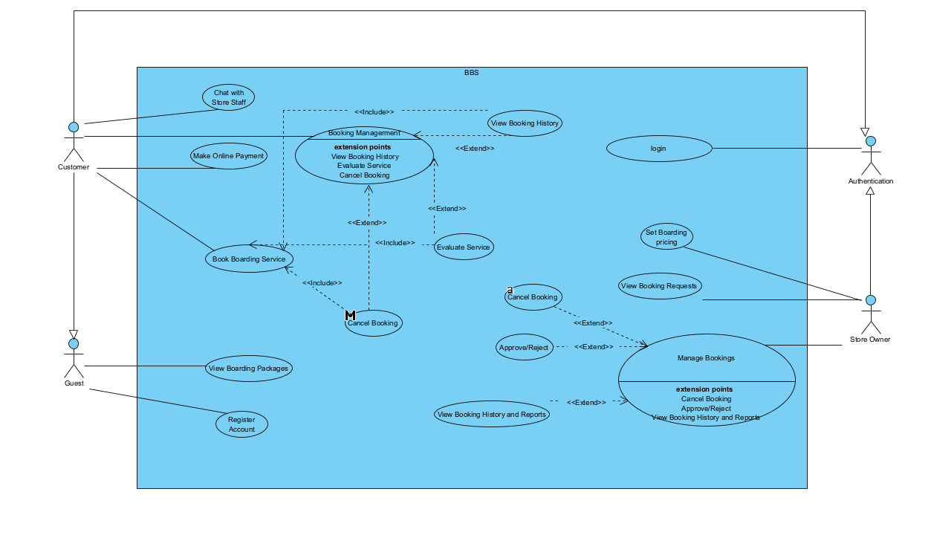

|  |  |  |
| --- | --- | --- |
| **#** | **Actor** | **Description** |
| 01 | Guest | A visitor to the system who has not logged in or registered an account. Guests can view general information about the boarding services and packages offered by the store. |
| 02 | Authentication | A system component or service responsible for authenticating users and managing their access to the system. It handles user authentication through registered accounts or integration with external authentication providers like Facebook. |
| 03 | Customer | A registered user of the system who can book bird boarding services, make online payments, request specific bird cages, view their booking history, evaluate the service, chat with store staff, and manage their account. |
| 04 | Store Owner | The owner of the ornamental bird store. The store owner has the authority to set the pricing for boarding service packages and cancel customer bookings. |

|  |  |  |  |
| --- | --- | --- | --- |
| **#** | **Use Case** | **Actors** | **Description** |
| UC-01 | View Boarding Packages | Customer | Allows customers to view detailed information about the available boarding service packages offered by the store. |
| UC-02 | Book Boarding Service | Customer | Allows customers to book a boarding service for their birds.  Steps:  1.Select the desired time period for boarding.  2.Select the boarding service package.  3.Request specific bird cages (optional). |
| UC-03 | Make Online Payment | Customer | Allows customers to make payments for their bookings through online payment systems (PayPal or VnPay).  Steps:  1.Provide payment details.  2.Confirm payment.  3.Receive payment confirmation |
| UC-04 | View Booking History | Customer | Allows customers to view the history of their past bookings. |
| UC-05 | Evaluate Service | Customer | Allows customers to provide feedback and evaluate the boarding service after using it. |
| UC-06 | Request Bird Cage | Customer | Allows customers to specifically request bird cages for their birds during the booking process. |
| UC-07 | Chat with Store Staff | Customer | Allows customers to communicate with store staff through a chat function within the system. |
| UC-08 | Register Account | Customer | Allows customers to register an account with the system.  Steps:  1.Provide required information (e.g., name, email, password).  2.Submit registration request.  3.Wait for account approval by store staff. |
| UC-09 | Set Boarding Pricing | Store Owner | Allows the store owner to set the pricing for the boarding service packages. |
| UC-010 | Cancel Booking | Store Owner | Allows the store owner to cancel a customer's booking.  Steps:  1.Identify the booking to be canceled.  2.Confirm the cancellation. |
| UC-011 | Payment Confirmation | Online Payment System | Handles the confirmation of successful payments made by customers through the online payment systems. |

Q4:

|  |  |  |
| --- | --- | --- |
| ID | Rule Definition | Use cases |
| BR-01 | Customer Registration: A customer account can only be created with a valid email address and a unique username. | Register Account |
| BR-02 | Boarding Availability: Customers can only book boarding services for dates with available capacity. The system checks cage size and bird quantity to ensure sufficient space for all birds. | Book Boarding Service |
| BR-03 | Payment Processing: A booking is only confirmed after successful online payment. The system accepts payments through secure payment gateways (e.g., PayPal, VnPay). | Book Boarding Service |
| BR-04 | Cancellation Policy: Customers can cancel bookings before the specified deadline (e.g., 48 hours) for a partial refund (e.g., 50%). Cancellations after the deadline forfeit the entire payment. | Book Boarding Service |
| BR-05 | Store Owner Approval: Store owners have the discretion to approve or reject booking requests. Reasons for rejection may include unavailability, policy violations, or customer history. | Book Boarding Service |

**Q5:**

Non-Functional Requirements:

1. Performance (Most Important):

Term: Response Time

Statements:

The system shall respond to user actions within four seconds (as specified in the SRS) for 90% of requests during peak load. Testers can simulate high user concurrency and measure average response times for various functionalities. Bookings, payments, and critical actions should be prioritized for testing.

System response time for critical functionalities (booking confirmation, payment processing) should not exceed five seconds under any load conditions. This ensures a smooth user experience even during peak usage. Testers can focus on critical functionalities and measure response times under various load scenarios.

b. Security:

Term: Data Security

Statements:

All customer account information, including personal information and payment information, must be encrypted.

The system should implement secure login protocols (HTTPS) to encrypt communication between user devices and the server.